Internal Quarterly Report

Date of Report: 4th Quarterly Report, October 1, 2025
Contract Number: 693JK32410013POTA
Prepared for: DOT PHMSA
Project Title: Assess and Prevent Threats in Conversion or Repurposing Pipeline Systems
Prepared by: DNV
Contact Information: Greg Morris, greg.morris@dnv.com, 614-761-1214
Tara McMahan, tara.podnar.mcmahan@dnv.com, 614-761-1214
For quarterly period ending: September 30, 2025

1: Items Completed During this Quarterly Period:

Task 2 Interim Deliverable: Written summary of the developed process components and flowchart for integrity-related considerations.

2: Items Not-Completed During this Quarterly Period:

Project is on schedule.

3: Project Financial Tracking During this Quarterly Period:
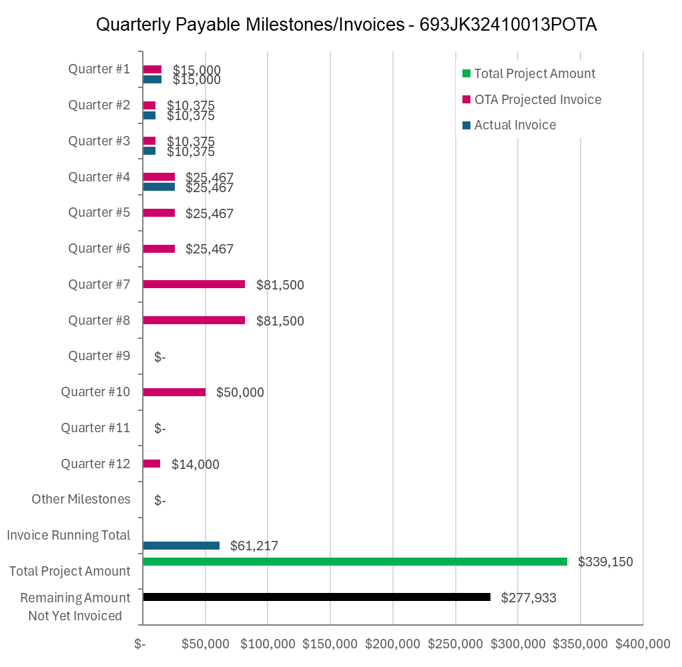

4: Project Technical Status –

DNV completed the Task 2 interim deliverable: “Written summary of the developed process components and flowchart for integrity related considerations.” The document was uploaded to the PRIMIS website and DNV’s project share site (PHMSA Repurposing Guidance Project - Home).

DNV will continue working on the next deliverable: Task 2 interim deliverable “Written summary of the developed process components and flowchart for operational considerations.”

The next Quarterly TAP meeting is scheduled for October 30, 2025.

5: Project Schedule –

The project is on schedule.

